**User Manual ICCI_Bank**

1.LoginPage

2.Apply for card

3.CRHomePage

3.1.Register Card

3.2.Make payment

3.3.Block Card

3.4.UnblockCard

3.5.SchemeReport

3.6.Transaction Statistics

3.7.Approved and Rejected-Pending Report

3.8.Revenue Statistics

4 CustomerHomePage

4.1 View Card Details

4.2View Card Usage

4.3 Online Transaction

5.ChooseScheme

1.LoginPage:

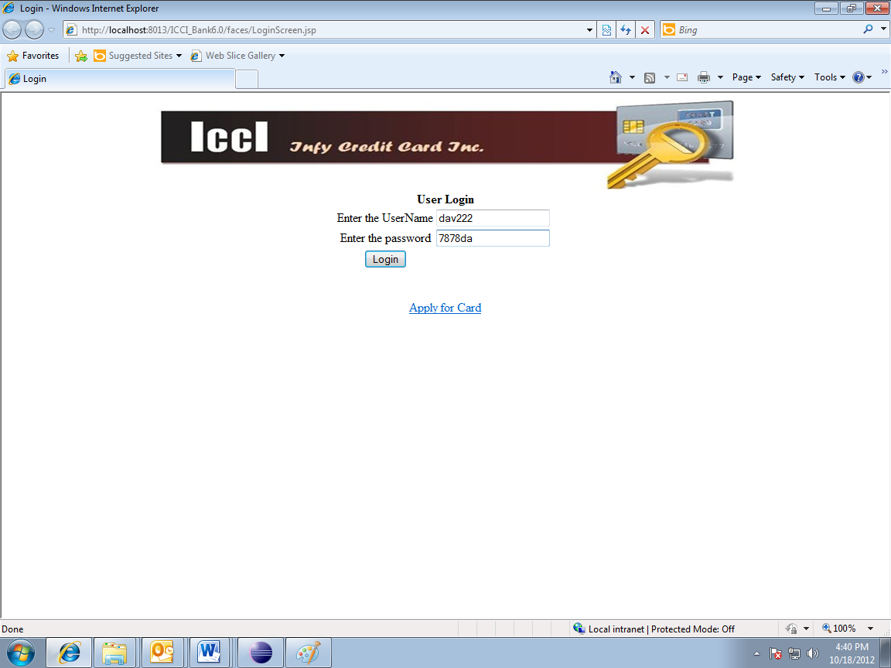First the user has to enter his respective user name and password. After doing this, he can click on the login button.

2. Apply for Card

The user has to fill up the form with each of the required fields. Then click on the apply button so the form can be submitted and finally an id is assign to the apply.

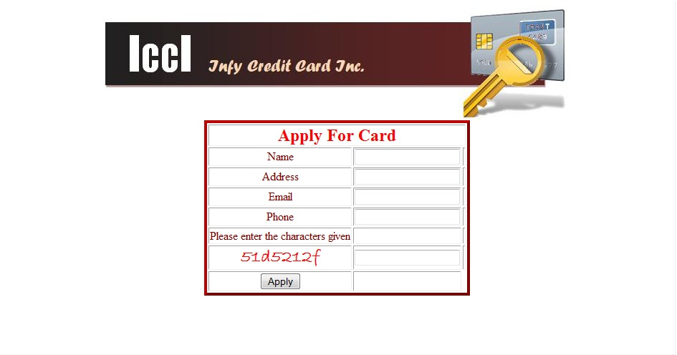

3. CRHome Page

In this page the user can visualize all the functionalities that can be done in the application.

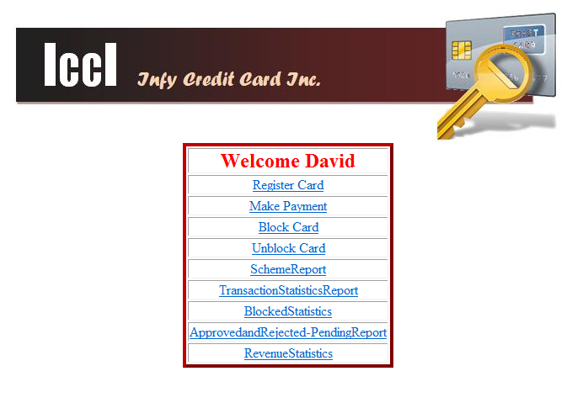

3.1 Register Card

The user can select an application that is already created and then can click on the approve button. After this, the number of the card is approving.

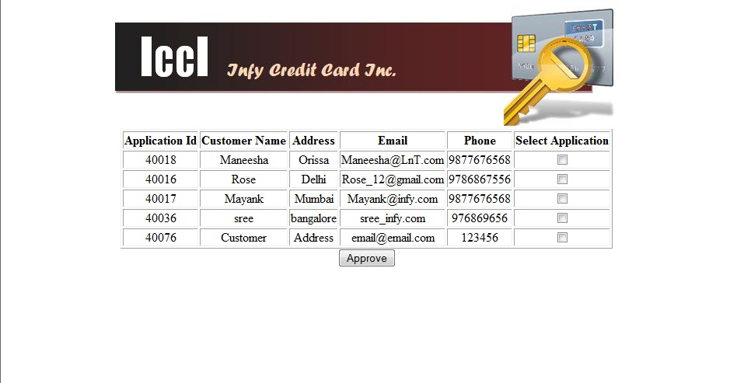

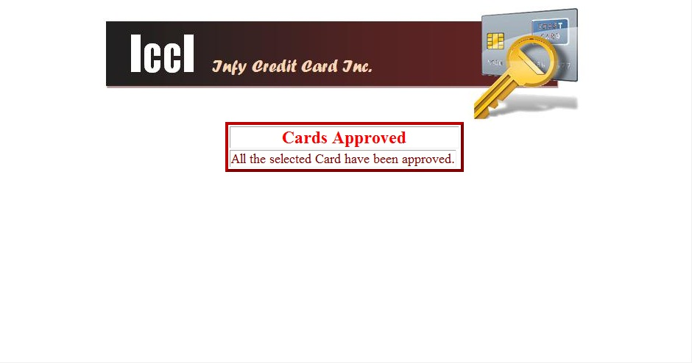

3.2 Make Payment

The user has to enter a valid card number so it can show the card’s details and the method of payment. Then he has to click on the getAmountDetail’s button so it can show the payment and his respective balance. If the user wants to make the make the payment, he has to click on the makePayment button; if it is successful an id is assign to it.

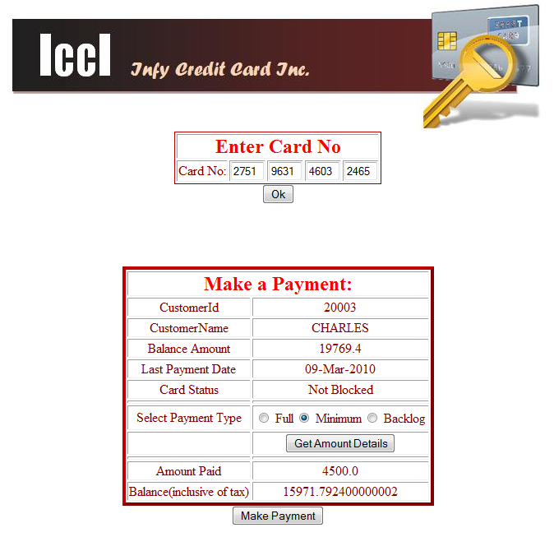

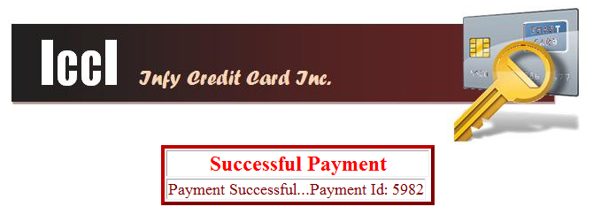

3.3.Block Card

The user has to enter a valid card number and also the reason provided by the application of why he/she is blocking the card. If the cause is justify then the card is eventually block.

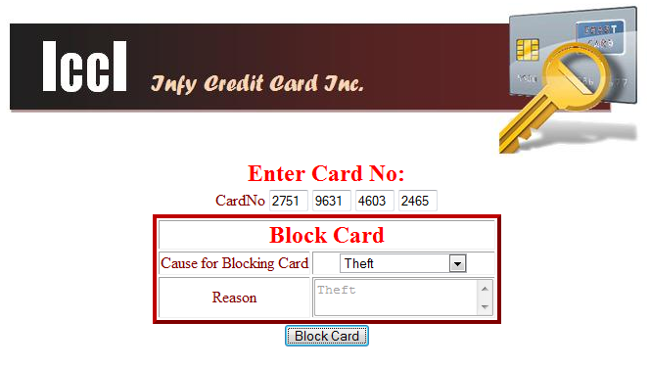

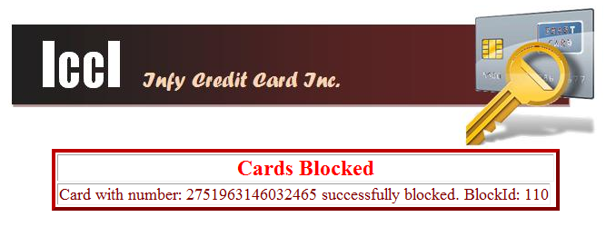

3.4.UnblockCard

The user again has to enter a valid card number and if the reason of the blocked card is “Payment Not Done” then the card is unblocked successfully. (It is the only way or reason of unblocking a card)

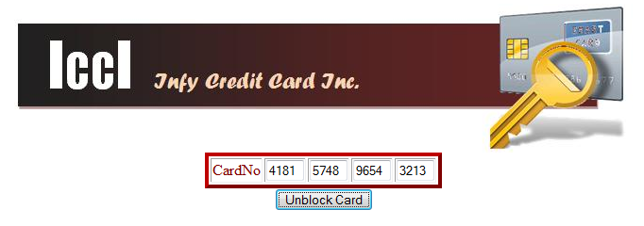

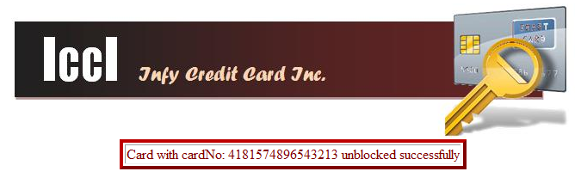

3.5.SchemeReport

The user has choose a scheme for his/her card. After doing this, a new window will appear with the customer’s id and the card numbers associated with that particular scheme. If there is not a scheme then a message will appear informing the user. If the user chooses a customer id and a card number, then the respective details of that customer and that card will be shown in the same page.

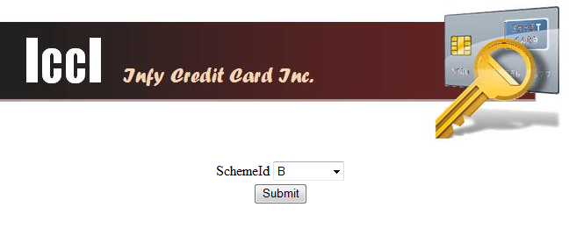

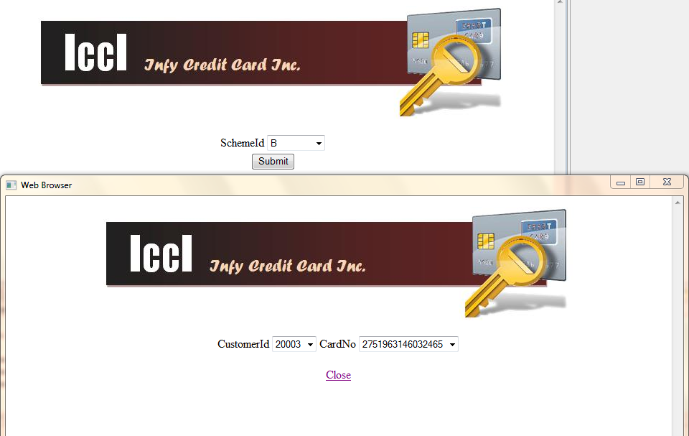

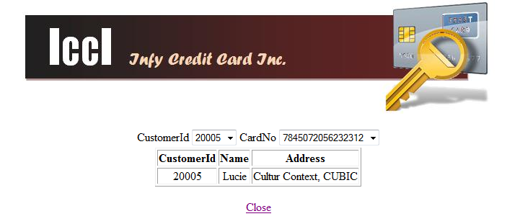

3.6.Transaction Statistics

The user has to enter the proper date on each of the required fields, after clicking on the submitted button, a data table with customer’s Name and the number of transactions will be shown between the dates entered. Then the user can press on any of the customer’s name or transaction and it will show the specific details.

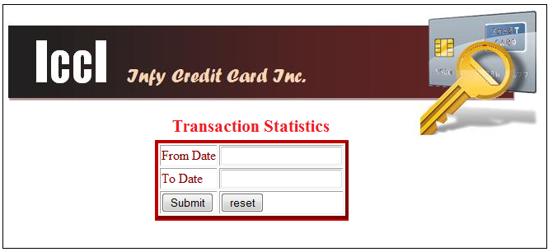

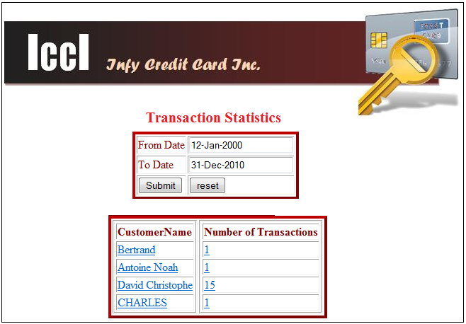

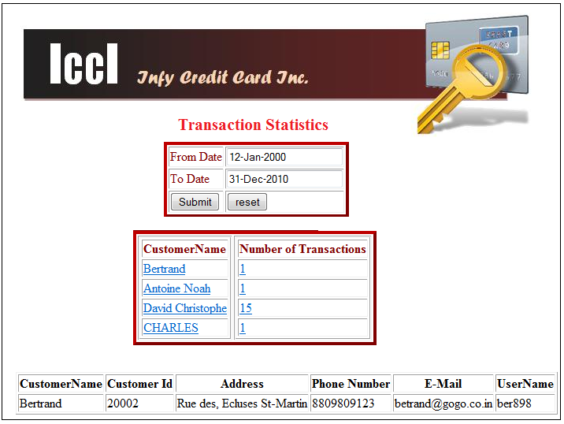

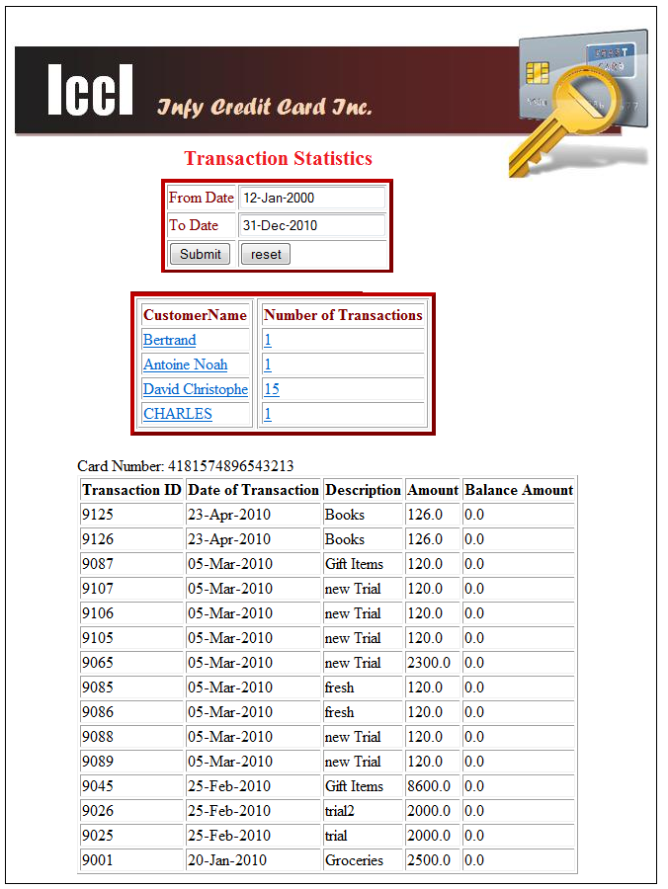

3.7.Approved and Rejected-Pending Report

The user has to enter the proper dates on which he wants to see all the approve and rejected cards. After doing this it will appear the respective percentage for each of the approve and rejected cards. If you choose either percentage (in this case approve) it will bring up all the card numbers and besides that it will show the respective details of the card, if this one is clicked on. If the rejected percentage is press then all the pending or rejected card’s details will appear as a report page.





If percentage of application approved is clicked :



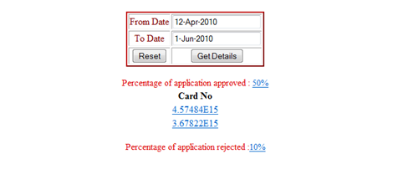

If Card No is clicked :

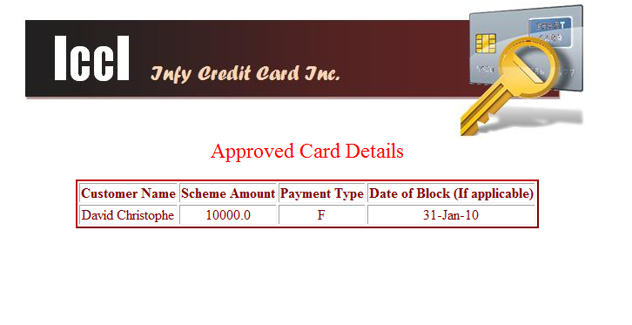

If percentage of application rejected is clicked :



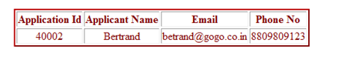

3.8.Revenue Statistics

The user has to enter the proper dates and ater clicking on the button, it will appear the profit, revenue and the expenditure of the dates that are between the entered dates.

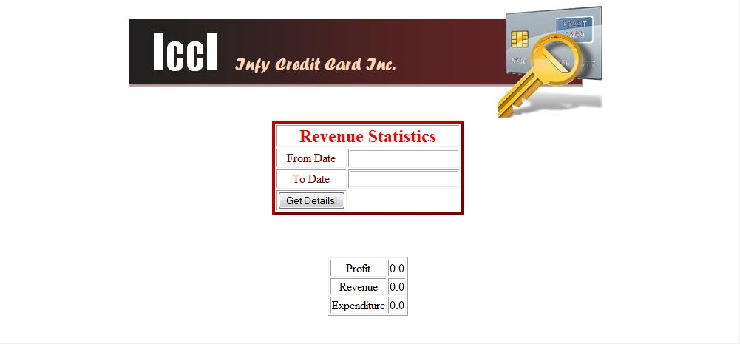

4 CustomerHomePage

4.1 View Card Details:

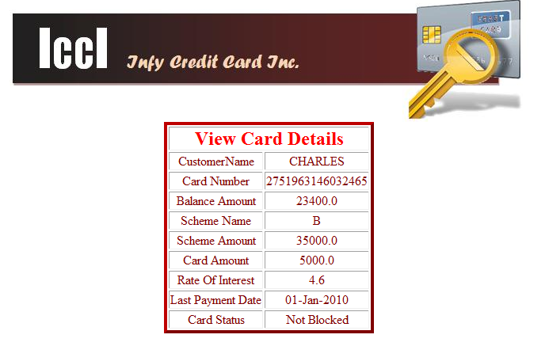

4.2View Card Usage

The user selects one option of the radio button options (This year or Previous year) in the next screenshot.

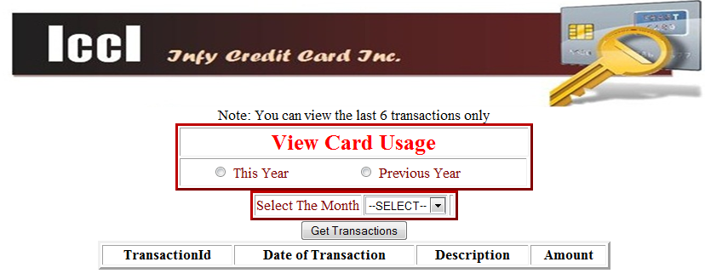

In the select month menu, there will be the last six months and the user has to select one option in order to show the transaction details in the next table shown.

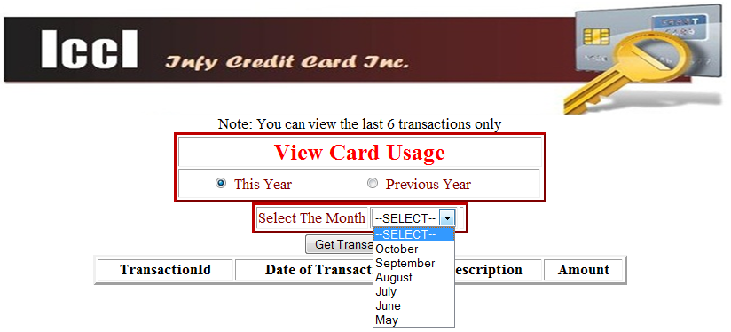

Note: If the current date is for example February, and the user selects “This Year” in the View Card Usage options, so in the select month menu will be show the months of the current year, otherwise if the user select “Previous Year”, so in the select month menu will be show the last months of the previous year, for the example: December, November, October and September.

The next table will be show when the user clicks the Get Transactions button.

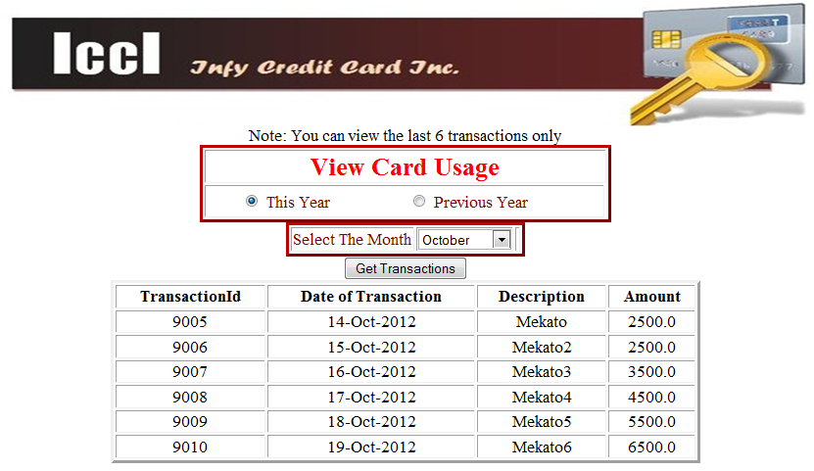

If the user card there are no transactions, so will be show the correct message “There are no transactions”.

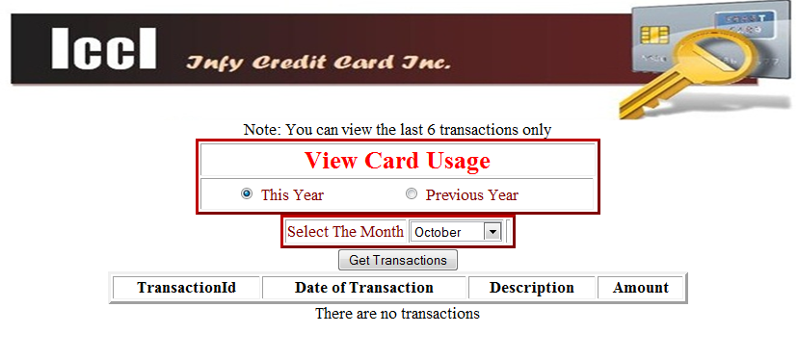

4.3 Online Transaction

The user Insert a description and an amount for the transaction then press the “pay online” button, after he will see the transaction details.

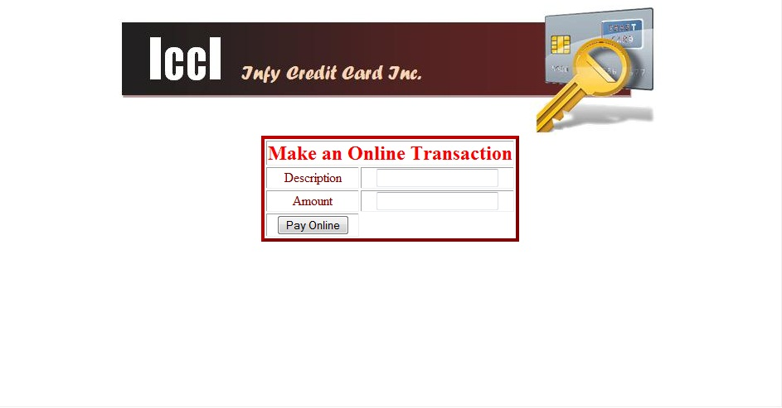

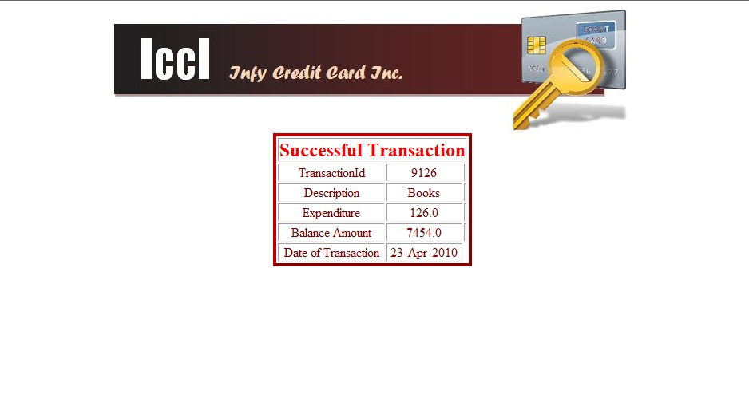

5.ChooseScheme

The next screenshot is the first page in order to choose one scheme for some user card. The user have to select one option of the Choose scheme id list.

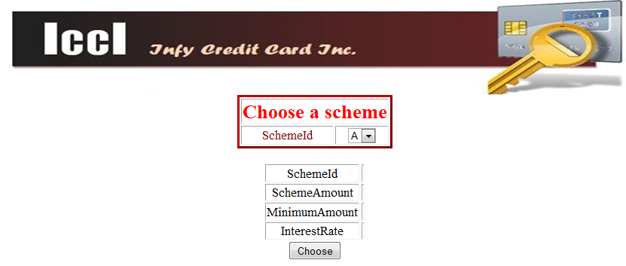

When the user select one option, will be show the respective details of the Scheme selected. The user has to click the Choose button in order to go to the Agreement page.

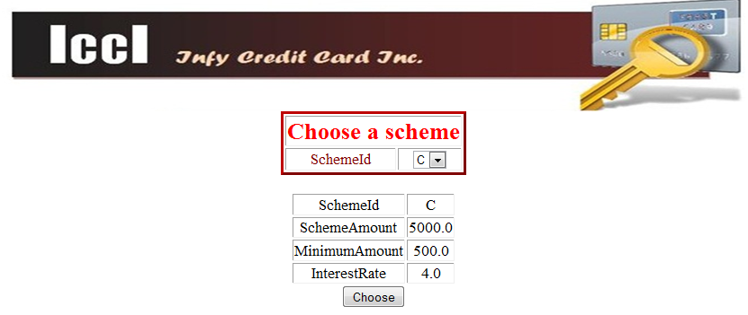

The user has to check the terms and conditions and click in the Submit button in order to go to the success page.

